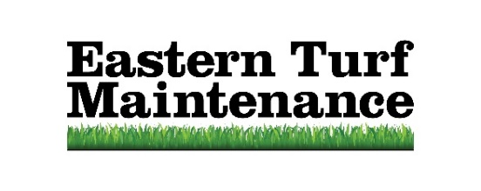
Lawn Manager

As an Eastern Turf Maintenance Lawn Manager, you will be required to provide timely lawn estimates and applications to residential or commercial customers.

Lawn Managers will be trained on products, services, communication skills, diagnosing and correcting landscape problems as well as sales, production, call log and many other facets of the company. We focus on providing great customer service as well as completing daily production goals.

Eastern Turf Maintenance is a locally- owned and operated company who prides itself on having a team with high character, honesty and integrity and would expect the same from any candidate applying. Position is based in Greenville, NC serving the greater Greenville, Wilson, & Kinston, NC areas. Company transportation provided on the job. Please email resume to support@etmlawncare.com.

Candidates should have:

• High school diploma/GED or six (6) months to one (1) year related experience and/or training in agronomy or horticulture and/or customer service or equivalent combination of education and experience required.

• Valid North Carolina driver's license.

• Valid North Carolina Pesticide license (or be willing to take the exam). (Cost for the first time taking the test is covered by Eastern Turf Maintenance and future attempts are paid by employee.)

Responsibilities include (but not limited to):

• Applies fertilizers and pesticides to lawns according to schedule, safety procedures, and label instructions.

• Responds on a timely basis to customer requests for telephone and in-person service visits.

• Completes required production forms and customer instructions.

• Measures the lawn of potential customers to provide them with an accurate cost of lawn care service.

• Maintains vehicle and equipment through cleanliness, safety, and general maintenance.

• Assists in maintaining cleanliness of facility.

• Addressing miscellaneous issues that may arise in your day-to-day operations.

Skillset:

• Ability to read and interpret documents such as safety rules, operating and maintenance instruction, and procedure manuals.

• Mathematical skills to calculate figures and amounts such as square footage, percentages, discounts, etc.

• Problem solving and attention to detail.

• Verbal and written communication skills.

• Time management and organizational skills, including punctuality for on-time attendance.

Benefits include:

• Health Care

• Dental

• Retirement Plan (401k) with Employer match, Life Insurance (Basic, Voluntary & AD&D)

• Paid Time Off (Vacation, Sick & Holidays)

• Short Term & Long Term Disability

• Training & Development

The day to day:
The physical demands described here are representative of those that must be met by an employee to successfully perform the essential functions of this job. The candidate who fills this position will need to be able to lift 50-pound bags, work outdoors, sit/stand and drive to complete a daily route as well as interact with customers.

